Vehicle Name/Type__________________Vehicle Registration ________________ Mileage ________________

Driver: ______________________ Department: ___________ Date of Check: ___________ Time In/Out: ______________

Mark each item as: Satisfactory X Defective/Missing N/A Not Applicable
Fluids |  | Lights/Electric |  | External Condition |  | Internal Condition
Engine Oil |  | Indicators |  | Door/Wing Mirrors |  | Seat Belts
Brake |  | Side Lights |  | Wiper Blades |  | First Aid Kit
Clutch |  | Headlights (Dipped) |  | Screen Washers |  | Fire Extinguisher
Power Steering |  | Headlights (Main) |  | Tyre Pressure |  | Dashboards Warning Lights
Auto Transmission |  | Warning Lights |  | Tyre Wear |  | Torch
Screen Wash |  | Reversing Lights |  | Tyre Damage |  | Warning Triangle
Fuel (Min ¼ full) |  | Horn |  | Spare Wheel |  | General Bodywork
Coolant |  | Windscreen |  | Cleanliness of number plate |  | Safety Certificate
Overall Cleanliness |  | Battery |  | Security of roof-rack |  | Registration book (Daftar)
 |  |  |  | Door Locking |  | Gate passes

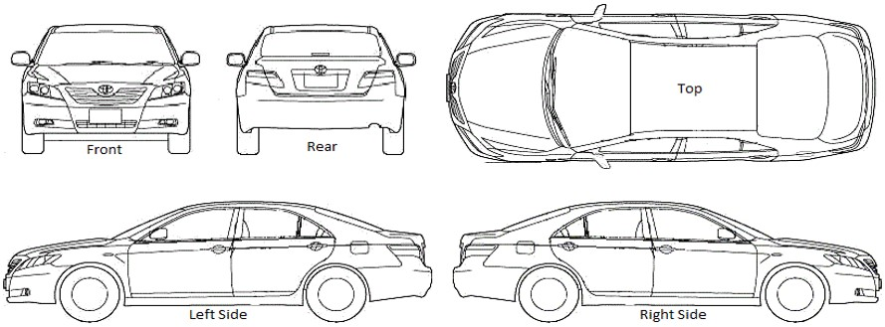
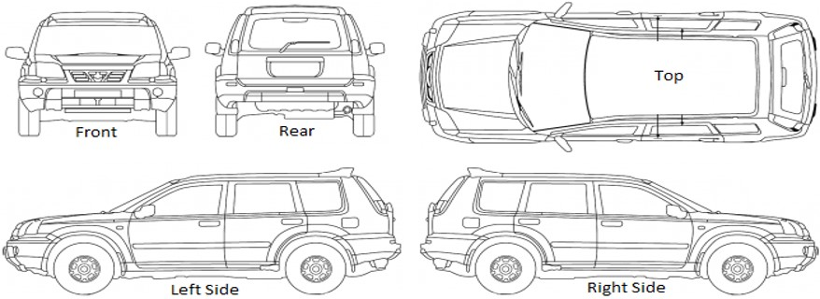
Comments:
d

The following vehicle checks are to be undertaken each trip for use.

Driver Signature Approved By

____________ _____________

